CRITICAL INFORMATION SUMMARY
UNWYRED MOBILE SIM ONLY PLANS

- Information about the Service

Unwyred post-paid plans use parts of Telstra’s 5G, 4G and 3G mobile network. These plans provide customers the ability to make and receive national and international voice calls, send, and receive messages using text (SMS) and multi-media messages (MMS), and to access data services including browsing the internet.

2. Information about Pricing
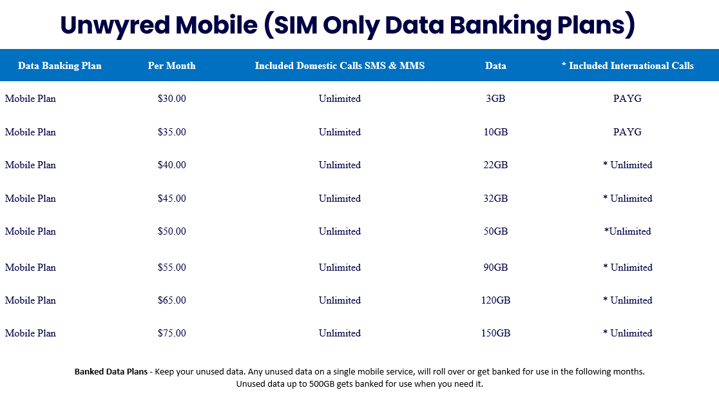

3. Early termination charges
The maximum charge for early termination is the minimum monthly charge, plus any excess call or data charges.

4. Additional data usage cost
$10 per extra 2 GB for use solely within Australia the price for Non-Standard Calls including International Direct Dial (IDD), Value Added Services, Special Calls, and Roaming can be varied by Unwyred at any time in its sole discretion Calls are rated in 60 second increments unless otherwise stated.

5. Data Banking
At the end of your monthly billing cycle, any unused data will go into your databank for use in the next billing period. Any data in your databank is forfeited if your plan is downgraded or if you disconnect the service. Your banked data will remain if you upgrade your plan to another C Blue plan. The maximum amount of your databank is 500 GB.

6. Included Unlimited Calls and Services
- Standard National voice calls (fixed line and mobiles)
- Standard National SMS
- Standard National MMS
- Standard National calls to 13xx and 18xx
- Voicemail deposits and retrievals
- *International calls and SMS from within Australia to
China, Germany, Greece, Hong Kong, India, Indonesia,
Ireland, Malaysia, NZ, Singapore, South Korea,
Thailand, UK, USA & Vietnam (15 included countries)

7. Excluded Calls and Services
- Directory services
- Video MMS
- Premium 19xx calls, SMS and MMS
- International roaming
-International calls, SMS and MMS outside the included 15 countries
- Any other calls or services not listed at Included Unlimited calls and services above

You can contact us by calling 1300 353 673, emailing us at support@unwyred.com.au, or by writing to us at UNWYRED ISP, PO Box 657, Murray Bridge SA 5253

Information about Unwyred Mobile network coverage and speed caps in Australia can be found at http://www.telstrawholesale.com.au/mobile-network

You will receive SMS usage alerts to your compatible device within 24 hours of reaching 50%, 85% or 100% of your included data allowance.

To check your data usage please dial *159# and press call.

If you are not satisfied with how your complaint has been addressed by Unwyred Mobile, you can contact the Telecommunications Industry Ombudsman (TIO) by calling 1800 062 058, or visiting their website at www.tio.com.au, by sending a fax to 1800 630 614, or you can write to the TIO at PO Box 276, Collins St West, VIC 8007.

International Roaming is available to credit approved customers on request. International Roaming is very expensive for all types of calls, messaging, and data. If you are concerned about the cost of International Roaming, you should not enable this service and should enquire about a local service in the country you are travelling in. Customers who use International Roaming should be particularly careful about data roaming costs. Unless required, you should ensure data roaming is not enabled on your handset or device. International Roaming call charges normally take much longer to appear on your account.

You should carefully monitor your usage to avoid high bills.

Premium Services by their nature are expensive. You should carefully read the terms and conditions of any Premium Services you use, the terms and conditions of any subscription based Premium SMS Services.

You can stop specific Premium SMS Services by sending a SMS reply with the word “STOP”. You can bar access to all Premium Services at any time by contacting Unwyred customer care. This Critical Information Summary has been prepared by Unwyred Mobile in accordance with the requirements of Chapter 4 of C628:2012 Telecommunications Consumer Protection Code.

